# Purpose

The purpose of this procedure is to describe the controls for managing the safety risks associated with Melbourne Water employees working in one or more of the following situations: alone, in an isolated or remote location.

# Scope

This procedure applies to all Melbourne Water employees whenever working is taking place that meets that definition of Lone Work, Remote Work or Isolated Work.

This procedure does not apply to scenarios where employees are working from an office during normal business hours or working from home. In these scenarios however, employees should always ensure that they have the ability to communicate with others and/or emergency services.

# Process

## Controls for working alone, in isolated and/or remote locations

A number of controls are available to support the management risks associated with lone, isolated or remote work.

The primary control is a standardised check-in/check-out protocol. The intent of this is to ensure that there is an ability to regularly connect and confirm workers’ safety in higher risk situations. This protocol has an embedded alert function to trigger an escalation in the event of a missed check-in. In the instance of an application outage or device malfunction, then a risk assessment shall determine suitable alternative method for check-in/out.

Other controls have been identified for various work scenarios. These are summarised in Table 1 below, along with the relevant check-in/check-out methodology for that scenario.

**Note:** In the instance where more than one situation is applicable, the control plan should consider all relevant controls.

Table 1: Check-in/check-out method and other controls associated with lone, isolated and remote work

|  |  |  |
| --- | --- | --- |
| Work situation | Check-in/Check-out method | Other controls relevant to the work situation |
| Lone Work | SHEQSY App | * First aid kit * Snake bite kit |
| Isolated Work | Garmin inReach | * First aid kit * Snake bite kit * Work in pairs * Monitor weather conditions |
| Remote Work Level 1 | SHEQSY App | * Remote First aid kit * Snake bite kit * Work in pairs * Monitor weather conditions * Extraction plan |
| Remote Work Level 2 | SHEQSY APP | * Remote First aid kit * Snake bite kit * Monitor weather conditions * Extraction plan * Suitable work vehicle * 8 people in Work Party * Carry defibrillator, torches, space blanket and chainsaws * Rescue equipment such as wilderness rescue stretcher where appropriate |
| Afterhours [duty roster](https://intranet.melbournewater.com.au/workinghere/officeandsitefacilities/rosters)* | SHEQSY App | * First aid kit * Snake bite kit |

*Check-in protocol only becomes relevant when the worker is called out. In an afterhours situation, attending a site/office is considered lone work.

Examples of lone, remote and isolated work activities and the associated check-in/check-out methods can be seen in Appendix 1.

## Check-in/Check-out Protocol

As per Table 1, the check-in/check-out protocol is performed either via the SHEQSY phone application or via a Garmin inReach device. The process is as follows:

1. Start a check-in/check-out session when commencing travel to destination.
2. Continue to execute check-ins every two hours
3. Finish a session when safely returned to home or office

**Note**: by default, the check-in frequency is set to a minimum of two hours. This frequency can be increased by teams to manage a heightened risk as deemed necessary.

### Managing Alerts

An alert will be trigger in the event that an employee or team:

* fails to check-in,
* fails to ‘complete’ an activity or
* presses the panic button

When an alert is triggered, the ART Call Centre (provided by SHEQSY/Safety Culture) will attempt to make contact with the user directly.

If the ART is unable to make contact, the alert will be escalated to Melbourne Water. **Error! Reference source not found.** outlines the escalation process for failed check-ins and failed activity completions. Figure 2 outlines the process for escalating a panic call.

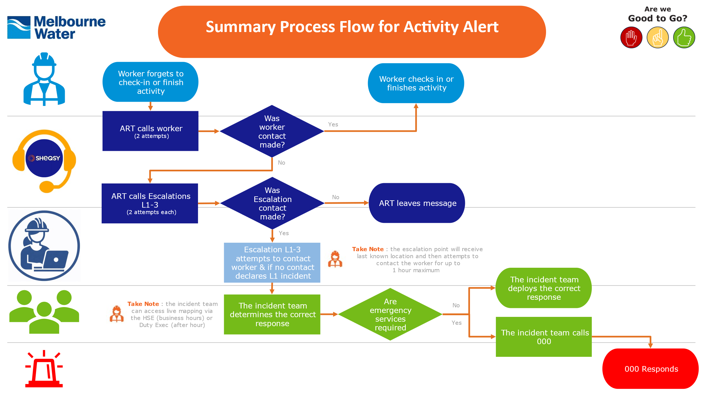

Figure 1: Escalation process for failed check-ins and failed activity completions

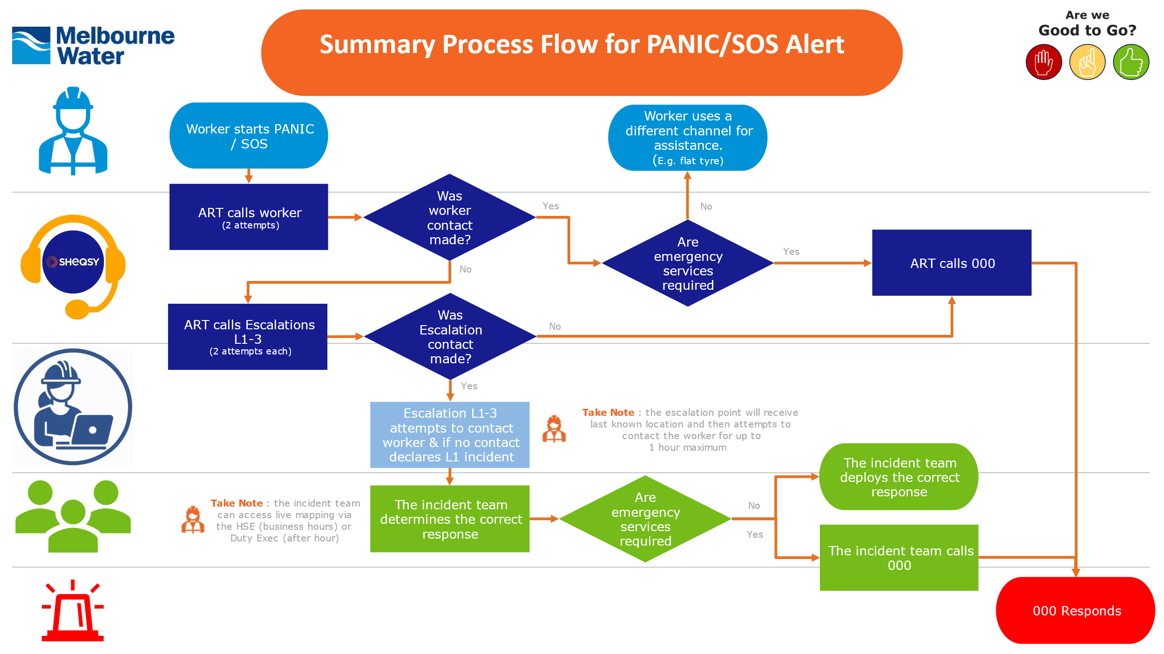

Figure 2: Escalation process for escalating a panic call

* While an upper limit of 1 hour has been set, the escalation point should consider the nature of the activity that was being performed by their team member, their location and the potential risks when determining the length of time taken to attempt to make contact. If deemed appropriate, the escalation point can progress through the escalation protocol immediately.

** If unable to make contact with the HSE team, proceed through the escalation protocol utilising the last known location snap shot referenced in the note below.

***Note:*** *to ensure the privacy of users is protected, access to the SHEQSY live mapping feature will be limited to use in an alert only and be restricted to the following users:*

*Business hours: HSE’s Safety Advisors*

*After hours: Duty Executives*

*This app is designed to improve the safety of our employees and cannot be used in any disciplinary action. In the instance that an alert is raised, a snapshot of the person’s last registered location will be sent to the escalation point. However, they will still not be able to see the live mapping.*

Specific escalation arrangements will be established directly in the SHEQSY App. The default arrangements are outlined in Table 2 below, following a maximum of 3 point escalation hierarchy. Customisation of these arrangements can be made within the App as required. It is recommended that a minimum of 2 points of escalation are created for custom arrangements.

Table 2: Default escalation arrangement – scenario dependent

|  |  |
| --- | --- |
| Scenario | Escalation arrangement |
| Normal work hours | Line manager of employee using the SHEQSY application  ↓  One-up manager  ↓  Department Head of/General Manager |
| On-call | Aligns with [duty roster](https://intranet.melbournewater.com.au/workinghere/officeandsitefacilities/rosters) structure and managers |

# Governance

## Performance monitoring

Usage of the SHEQSY app is to be monitored for information purposes through the HSE SHEQSY PowerBI Dashboard.

There are no specific targets associated with app usage.

## Assurance

Assurances are completed in alignment with the HSE Assurance Framework. Relevant activities are outlined in Table 3.

Table 3 - Assurance Activities

|  |  |  |  |
| --- | --- | --- | --- |
| **Assurance activity** | **Checklist ID** | **Responsible** | **Frequency** |
| Critical Control Evaluation | TBD | HSE Team | TBD |

# Responsibilities

|  |  |
| --- | --- |
| Role | Responsibility |
| Work initiator/planner/Project Manager | * Where possible, eliminate the need to work alone and/or in remote and/or isolated locations * Identify in works description if work is alone, isolated and/or remote * Determine remoteness Level (1 or 2) if applicable |
| Worker/Work crew | * As required:   + Perform check-in protocol   + Carry Garmin InReach device   + Prepare risk assessments and control plan   Implement lone, remote and isolated work controls |
| Manager of worker/work crew | * Ensure workers have access to SHEQSY app and Garmin InReach devices where required * Review extraction plans prior to any work considered Remote Work Level 2 * Set-up escalation points for workers where required * Promptly execute escalation process in the instance of an unsuccessful check-in |
| After hours Duty Officer/ work crew | * Perform check-in protocol when required to leave and attend a site visit * Implement lone, remote and isolated work controls as required |
| After hours Duty Manager | * When rostered on and during afterhours, promptly execute escalation protocol in the instance of an unsuccessful check-in |
| HSE team | * Govern this procedure * Manage the SHEQSY system * Support users on the SHEQSY system |

# Awareness and Training

The [Welcome to SHEQSY](https://melbwater.sharepoint.com/sites/WelcometoSHEQSY) Intranet Page contains further information and instruction on the app/device. It contains information such as how to:

* perform the check-in
* set up custom escalations

# Definitions

|  |  |
| --- | --- |
| Reference | Definition |
| Lone Work | A person who is performing their work alone for a 2 hour period or longer. Includes after-hours call outs in an office or field environment.  Note, this does not include performing tasks alone whilst part of a work crew. |
| Remote Work Level 1 | Work performed in a remote location where access to emergency services is considered *restricted*. *Restricted* access to emergency services includes situations where:   * travel time is >1 hour from a hospital emergency department and/or   work is performed >30mins from a publicly accessible road. |
| Remote Work Level 2 | Work performed in a remote location where access to emergency services is *very* restricted. *Very restricted* access to emergency services includes situations where:   * access to a hospital emergency department is via airlift and/or * work is performed at a location that is >30mins from a publicly accessible road and   the worksite itself is >30 minutes on foot from the work vehicle. |
| Isolated Work | Work performed in a location where the worker(s) are unable to make reliable or consistent direct and instantaneous contact (including via mobile phone) with others and/or emergency services.  Note, advanced communication devices such as Trunk radios or satellite phones do not negate this definition as they’re considered controls for managing Isolated Work risks. |
| Occupational Violence and Aggression (OVA) | Refers to any act or behaviour that may cause harm, threat, intimidation, or injury to an individual within the workplace or during work-related activities. This includes physical violence, such as hitting, pushing, or assaulting someone, as well as verbal aggression, such as yelling, threats, or harassment.  Note, workplace violence and aggression can occur between employees, between employees and clients or customers, or even from external sources such as intruders. |
| SHEQSY | SHEQSY is a smartphone application (app) designed to assist in managing risk associated with working alone. |
| Garmin inReach device | A Garmin inReach device is a satellite tracking and communication device that allows employees travelling and working in areas where mobile reception is limited or unavailable to communicate and activate a SHEQSY session.  Note, the device must be an integrated SHEQSY device to utilise the SHEQSY check-in functionality |
| Field Work | Work performed in the field (not in an office) |
| MWC office | Melbourne Water offices including field offices. |

# References

|  |
| --- |
| Document title |
| [H&S PRO Good to Go](https://inflo.mwc.melbournewater.com.au/inflo/cs.exe/properties/50643388) |
| [Welcome to SHEQSY](https://melbwater.sharepoint.com/sites/WelcometoSHEQSY) |
| [Occupational Health and Safety Act 2004](https://www.legislation.vic.gov.au/in-force/acts/occupational-health-and-safety-act-2004) |
| [Occupational Health and Safety Regulations 2017](https://www.legislation.vic.gov.au/in-force/statutory-rules/occupational-health-and-safety-regulations-2017) |
| [Rosters (intranet page)](https://intranet.melbournewater.com.au/workinghere/officeandsitefacilities/rosters) |

# Appendices

|  |
| --- |
| Appendices |
| Appendix A – Examples of Lone, Remote and Isolated Work |

# Stakeholder Consultation

|  |
| --- |
| Stakeholders |
| HSE Team |
| Health and Safety Representatives |
| Service Delivery |
| Security & Emergency Management Specialist |

# Document History

|  |  |  |  |
| --- | --- | --- | --- |
| Date | Reviewed/  Actioned By | Version | Action |
| March 2025 | Senior Manager HSE Risk & Management Systems | 22 | Added hyperlinks to the Roster intranet page |
| February 2025 | Senior Manager HSE Risk & Management Systems | 21 | Major update. Changes include:   * Definitions tab added * Clarified the difference between isolated and remote * Reworked to focus on MW’s check-in/out protocol with additional controls to be considered * Introduced the SHEQSY app and Garmin inReach devices * Simplified the four levels of remote down to two * Included an escalation protocol * Added an assurance section * Included references |
| January 2024 | Information Management | 19, 20 | System administration updates  (no changes to document) |
| Sep 2021 | SHEQ Manager | 18 | Updated and consolidated procedure |
| Nov 2019 | Project & Support Coordinator | 17 | Minor update no change made to context of document.  Removed reference to OHS Act & Regs.  Updated version number in line with inflo version control. |

# Appendix A – Examples of Lone, Remote and Isolated Work

|  |  |  |  |  |  |  |
| --- | --- | --- | --- | --- | --- | --- |
| Work description | Lone Work | Remote Work Lvl 1 | Remote Work Lvl 2 | Isolated Work | Check-in method | Explanation  *Consider the Recommended Control Strategies* |
| A worker is required to visually inspect a valve on a customer’s farm in an urban area. The valve is located 3kms from the road. Phone reception at the location is reliable | Y | N | N | N | SHEQSY App | Worker is performing the task alone. For the purpose of the example it is assumed that the farm is not in a remote location. |
| A worker walks alone around the back of a depot store to check on pipe materials when other people are on site | N | N | N | N | NA | The worker is still at a MW site and is not alone for >2 hours. |
| A work crew is clearing fire access tracks in the Upper Yarra Catchment | N | Y | N | Y | Garmin InReach | Work is being performed in a crew and not alone. Upper Yarra phone reception is unreliable. Work is being performed on access roads and is therefore not Remote Lvl 2 |
| A worker is called out at 11.00pm to investigate an alarm at Winneke | Y | N | N | N | SHEQSY App | Worker is alone and afterhours. |
| A work crew planting along a metro waterway but sections are known to be communication black spots. | N | N | N | Y | Garmin InReach | Reception is known to be unreliable. |
| A Project Manager is visiting a site where their travel time is >2 hours and travel to a hospital emergency department is >1 hour from the site. | Y | Y | N | N | SHEQSY App | Working alone for >2 hours for the travel and then the site is Remote Lvl1. Has reliable reception at all points. |
| A worker conducting a series of drainage inspections in a metro area over the course of the day | Y | N | N | N | Y | Worker is working alone for >2 hours. |
| A work crew doing a pit run along a metro waterway with reliable work phone reception | N | N | N | N | NA | Workers working in a crew, in metro area with reliable reception |
| Work description | Lone Work | Remote Work Lvl 1 | Remote Work Lvl 2 | Isolated Work | Check-in method | Explanation  *Consider the Recommended Control Strategies* |
| A work crew performing weed control along waterways in the Maroondah catchment | N | N | Y | Y | Garmin InReach | It is anticipated that the work crew will at times not be able to park close to the site and will have to walk to the waterway. Reception in the Maroondah catchment is known to be unreliable. |
| A worker travelling to and meeting a customer. | N | N | N | N | NA | Assuming the travel time is <2 hours and the meeting location has good reception, this does not meet any of the definitions. However, if it is determined that the worker could be at risk, a SHEQSY check-in could be established to assist in managing the risk. |
| A sewerage operator is called after hours to attend the Mordialloc wet weather pumping station in Braeside Park. | Y | N | N | N | SHEQSY App | Worker is working alone after hours. |
| A water supply duty officer is called out to Wantirna Reservoir during BH. Travel and work time >2 hours. | Y | N | N | N | SHEQSY App | Worker is working alone |
| A Water supply operator is working behind MW locked gates deep in the Thomson catchment (4x4 access only) | Y | N | Y | Y | Garmin InReach +  Control plan | Worker is working alone in a remote level 2 area (Very Remote/ restricted access) and is isolated as there is no mobile connection. |
| A water supply operator is scheduled to access a tank for sampling at St Albans tank farm alone. Estimated combined travel and work time > 2 hours | Y | N | N | N | SHEQSY | Worker is working alone for > 2 hours. |
| An operator is called to respond to a bird watcher whose vehicle has become bogged at WTP conservation area where there is patchy reception. Estimated combined travel and work time <2 hours | N | N | N | Y | Garmin inReach | Due to the patchy network, the worker would take a spare site Garmin inReach device to call for help or ask for assistance if required. |